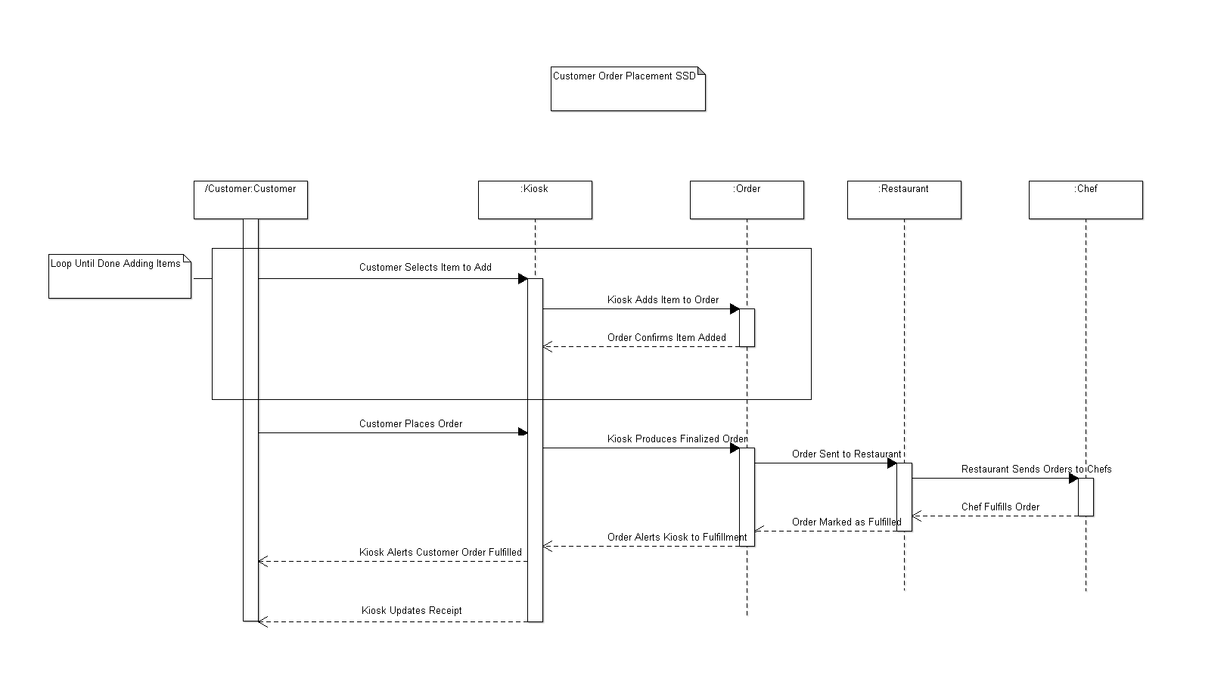

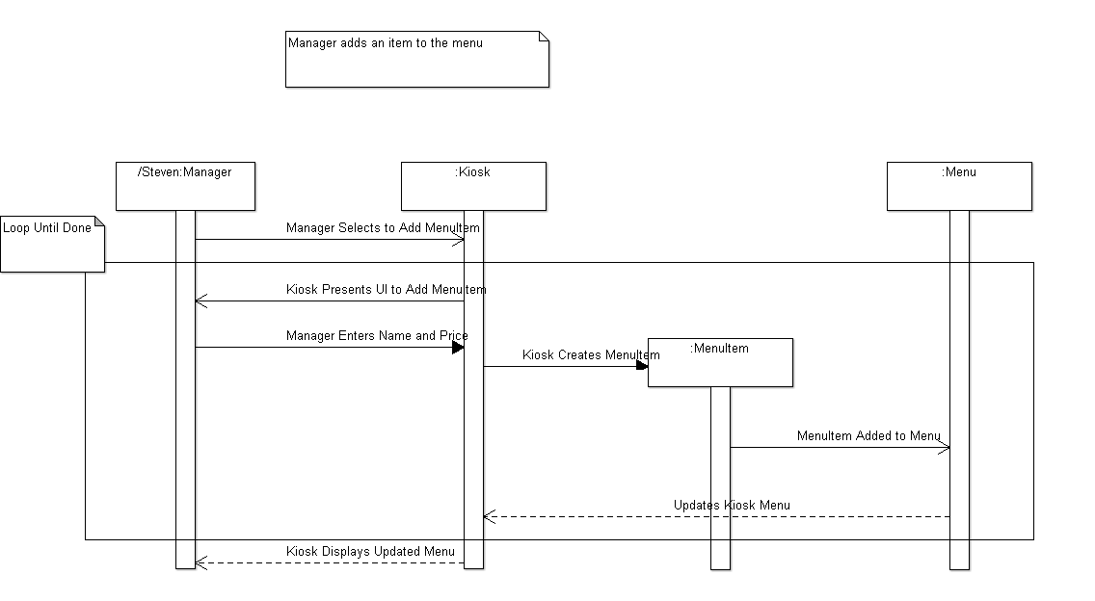

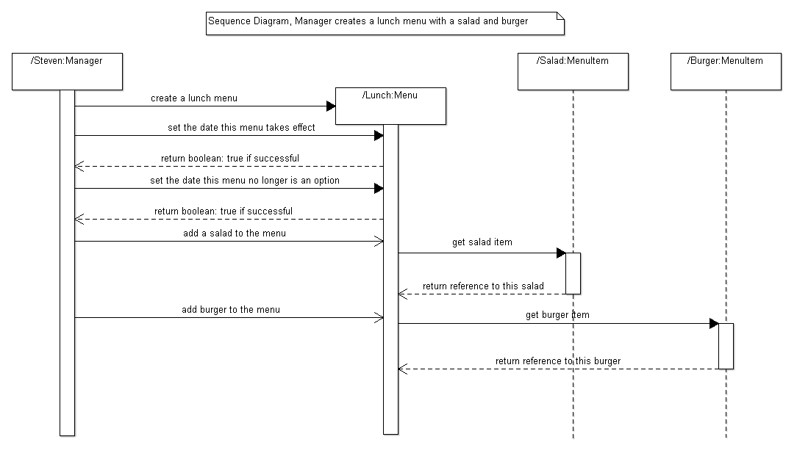

**System Test Plan**

**Manager Tests**

A set of tests designed to ensure that the manager can fulfill his roles. Namely, the manager must be able to create a new menu from nothing and must also be able to edit an existing menu. See supporting use case documentation for a fuller look at how these are done.

1. The manager must be able to create a menu from scratch and view that menu.

Precondition: None

Postcondition: New menu created and available to view.

2. The manager must be able to edit an existing menu.

Precondition: A menu exists (fail if you can edit a nonexistent menu, try never to reach that point).

Postcondition: Menu has successfully been edited and is now available for viewing.

**Customer Tests/Kiosk Tests**

Overall tests for the customer will revolve around Order manipulation. An Order can be created by the Customer, edited, and submitted to the system for fulfillment. A Customer may also cancel an Order before it is submitted but not after (as far as I know).

1. Customer has to be able to create an order.

Precondition: None

Postcondition: Customer has created and placed an order.

2. Customer edits the order before submission.

Precondition: An in progress order exists.

Postcondition: Customer has successfully changed the order.

**Chef Tests**

The Chef class exists only to complete Orders and update the Ingredient count which may be handled on the Order side of things whereas ensuring enough Ingredients exist to complete an Order in the first place is done by the Chef.

1. The chef must be able to fulfill an order; changing the status from incomplete to complete

Precondition: An incomplete order exists.

Postcondition: The order has been completed, inventory updated to reflect the removal of stock.

Fails if an order can’t be completed due to inventory constraints (avoidable?).

**Cashier Tests**

Cashiers are primarily a go between for taking payments and handling Orders.